Create the following circuit and test it out using command prompt:

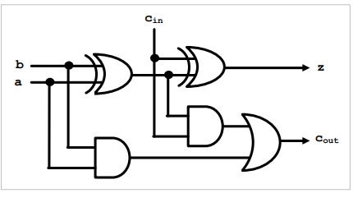Note that the circuit has three 1-bit inputs and two 1-bit outputs. It is made up of two xor gates, two and gates, and an or gate.